 

Krishnankoil Near Madurai in Tamilnadu

A

Project Report

On

“IOT Home Automation Using Raspberry Pi”

For The Course

Introduction to Python Programming

SUBMITTED BY

G.V.S.Surya Akash(Reg:9919004102)

D.Achuth(Reg:9919004066)

G.Mahendra(Reg:9919004088)

L.Anil Kumar Reddy(Reg:9919004362)

GUIDED BY

Prof.R.Raja Subramanian

SUBMITTED TO

Kalasalingam Academy of Research and Education

1. INTRODUCTION

2. COMPONENTS

3. ANALYSIS

4. CODE USED FOR THE RASPBERRY PI

5. CODE USED FOR THE PYTHON

6. CONCLUSION

7. REFERENCES

Internet of things is a technology of the future that has already started to touch our homes. Here we propose an IOT based home automation system using raspberry pi that automates home appliances and allows user to control them easily through internet from anywhere over the world.

Our proposed system consists of a microcontroller based circuit that has lights and fan connected to it along with LCD display and Wifi connector interfaced with raspberry pi. Our system interacts with out online IOT system that IOT Gecko free web interface for controlling our home appliances with ease. After linking with IOT Gecko, the user is allowed to send load switching commands over IOT to our circuit

The circuit receives the commands over IOT by connecting to internet using wifi connector and then the raspberry processor processes these commands. After this the processor now processes these instructions to get user commands. It then displays these on an LCD display. Also it operates the loads (lights and fan) for switch them on/off according to desired user commands. Thus we automate home appliances over internet using raspberry pi.

**Automation has been a feature of science fiction writing for many years, but has only become practical, since the early 20th Century, following the widespread introduction of electricity into the Office cabin and the rapid advancement of information technology. Automation can control application by using the Raspberry-Pi. The main objective is to control the electrical appliances in office cabin by using internet, so it is used to interface Raspberry Pi with Wi-fi. The Raspberry Pi is interfaced with Sensors to sense the atmospheric conditions. It is also interface with relays which can be turned ON/OFF by the controller using the IOT. Software system can be built in three various programming languages and can be controlled via the internet using webpage protected with a username and password to make sure that it cannot be hacked.**

**Hardware Specifications**

* Rectifier
* Regulator
* LCD Display
* Relay Driver
* Power Supply
* Lamps
* Fan
* Wifi Connection Modem
* Resistors
* Capacitors
* Diodes
* **Raspberry pi3**
* A SanDisk Ultra 16 GB Micro SD card for installing the OS
* Relay Modules as per the requirements – One relay module can replace one switch, so we need one relay module for each ON/OFF switch
* Connecting wires – As per the requirement
* Breadboard
* MCP23017 – I2C I/O Expander
* Electronic devices [Light bulbs] for performing the automation. These are the basic requirements for building a stable project of Simple Home Automation

**Software Specifications**

* Linux OS
* Programming language :Python

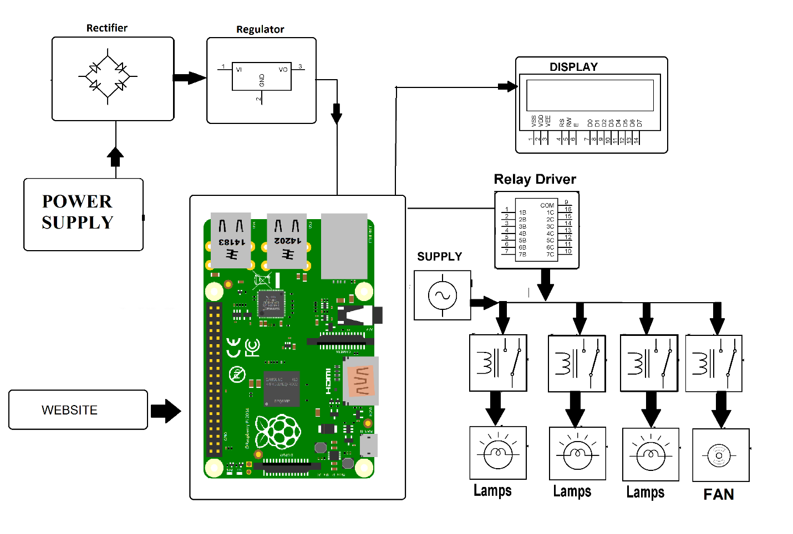

[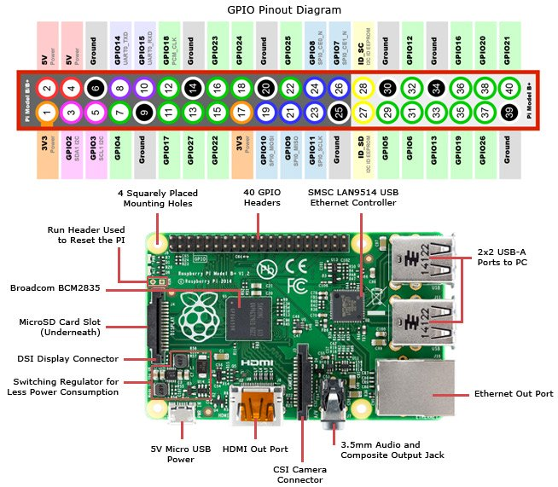](https://www.google.co.in/url?sa=i&rct=j&q=&esrc=s&source=images&cd=&ved=2ahUKEwi_ro_qmMLmAhXQ6nMBHSbEAtMQjRx6BAgBEAQ&url=https://www.jameco.com/Jameco/workshop/circuitnotes/raspberry-pi-circuit-note.html&psig=AOvVaw32PMAHQCqNweHlgO7iNsvE&ust=1576861446846753)

RASPBERRY PI 3

Raspberry pi is low cost minicomputer. It is possible to connect Monitor of PC as well as television to the Raspberry pi. Mouse and Keyboard can be connected to the Raspberry pi. All models having a Broadcom system on a chip, it includes an ARM compatible central processing unit (CPU) and an on-chip graphics processing unit. CPU speed ranges from 700 MHz to 1.2 GHz for the Pi 3. On board memory range from 256 MB to 1 GB RAM. Secure Digital (SD) cards are used to store the operating system and program memory. Most of the Raspberry pi board are having USB ports, HDMI post, DSI port, Audio jack, 40 GPIO pins, In-built Bluetooth, WIFI and so on.

//#define BLYNK_DEBUG

#define BLYNK_PRINT stdout

#ifdef RASPBERRY

#include <BlynkApiWiringPi.h>

#else

#include <BlynkApiLinux.h>

#endif

#include <BlynkSocket.h>

#include <BlynkOptionsParser.h>

static BlynkTransportSocket _blynkTransport;

BlynkSocket Blynk(_blynkTransport);

static const char *auth, *serv;

static uint16_t port;

#include <BlynkWidgets.h>

int buttonPin = 17; //GPIO17 Pin on the Pi

bool buttonState = false; //Used to store the previous state of the button

void setup()

{

Blynk.begin(auth, serv, port);

pinMode(buttonPin, INPUT); //Set GPIO17 as input

pullUpDnControl (buttonPin, PUD_UP); //Set GPIO17 internal pull up

}

void loop()

{

Blynk.run();

if(buttonState != digitalRead(buttonPin)) //check the button state against its last known value, if true:

{

if(digitalRead(buttonPin) == TRUE) //if true, set the Virtual Pin "V0" to a value of 0 (full off)

{

Blynk.virtualWrite(V0, 0);

}

else{

Blynk.virtualWrite(V0, 255); //Else we set the virtual pin "V0" to a value of 255 (full on)

}

}

else {} //if last value = current value, we do nothing.

buttonState = digitalRead(buttonPin); //update the button state.

}

int main(int argc, char* argv[])

{

parse_options(argc, argv, auth, serv, port);

setup();

while(true) {

loop();

}

return 0;

}

from Adafruit_IO import*

import RPi.GPIO as GPIO

import time, smbus2

ADAFRUIT_IO_KEY = 'fcd3eba32a8e4002a5ea9263d6ddb6f3'

ADAFRUIT_IO_USERNAME = 'Arjun007'

aio = Client(ADAFRUIT_IO_USERNAME, ADAFRUIT_IO_KEY)

bus = smbus2.SMBus(1)

relay_1 = 18

relay_2 = 23

fan = 24

GPIO.setwarnings(False)

GPIO.setmode(GPIO.BCM)

GPIO.setup(relay_1,GPIO.OUT)

GPIO.setup(relay_2,GPIO.OUT)

GPIO.setup(fan,GPIO.OUT)

i2cAdd=0x48

A0=0x40

A1=0X41

A2=0X42

A3=0X43

def temp():

return 2*bus.read_byte_data(i2cAdd,A0,force=None)

'''

feed = Feed(name="Counter")

response = aio.create_feed(feed)

'''

'''

while True:

print('sending count: ', 50)

aio.send('temperature', 50)

time.sleep(10)

'''

while True:

aio.send('temperature',temp())

time.sleep(10)



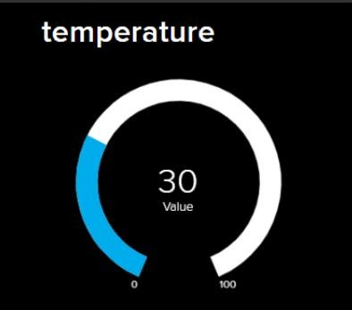

The work for IoT based home automation is completed successfully using internet source and Raspberry pi.

It is reliable and scalable home automation system with low cost and easy to implement.

It makes human life easy and comfortable.

It is possible to operate home appliances from any part of the globe.

These kinds of home automation systems are required because human can make mistakes and forgot to switch off the appliances when there is no use and in this case, they are useful in order to utilize the power effectively and also in a secured manner

[1] D. Norris, The Internet of Things: Do-It-Yourself at Home Projects for Arduino, Raspberry Pi and BeagleBone Black. Tab Electronics, 2015.

[2] D. Giusto, A. Iera, G. Morabito, and L. Atzori, The Internet of Things. New York, NY: Springer New York, 2010

[3] Raspberry pi as a sensor Web node for home automation Vladimir Vujovic, Mirjana Maksimovic

[4] A. Z. Alkar and U. Buhur, “An internet based wireless home automation system for multifunctional devices,” IEEE Trans. Consum. Electron., vol. 51, no. 4, pp. 1169–1174, Nov. 2005.

[5] Jump up Bush, Steve (25 May 2011). “Dongle computer lets kids discover programming on a TV”. Electronics Weekly. Retrieved 11 July, 2011

[6] Horan B. Practical Raspberry Pi. USA: Apress; 2013